Lab 3

*CST 311, Introduction to Computer Networks, Fall 2020*

**READ INSTRUCTIONS CAREFULLY BEFORE YOU START THE LAB.**

This lab is due on Sunday, November 15, 2020.

Lab must be submitted electronically to iLearn on <https://ilearn.csumb.edu>  by 11:55 p.m. on the due date.  Late lab assignments will not be accepted.

Lab must in pdf format only. Any other formats will not be accepted.  The naming convention of the file should be Lab3_yourlastname.pdf. **Put your name in the document as well.** Your lab submission should present the answers in the original order and be properly labeled.

This lab is worth 50 points. Each part of a question carries equal weight unless specified otherwise. This lab must be submitted individually.

Name :   ___________________________________________________________

## Install OpenDaylight SDN Controller

Follow the instructions at:

<http://www.brianlinkletter.com/using-the-opendaylight-sdn-controller-with-the-mininet-network-emulator/>

to install and run the OpenDaylight (ODL) SDN Controller in another Virtual Machine on your computer. Use host-only networking on it and also on your existing Mininet VM so that the two VMs can communicate with each other via TCP/IP. You will likely encounter problems when following the instructions. Please use your resources (web searches, #cst311 Slack channel, etc.) to get over the hurdles so that you can complete the assignment.

Turn in screen shots showing your working network that uses the ODL Controller, e.g.:

mininet@mininet-vm:~$ sudo mn --topo linear,3 --mac --controller=remote,ip=192.168.56.101,port=6633 --switch ovs,protocols=OpenFlow13

(Note: The IP address of your ODL Controller may be different.)

mininet> pingall  
*** Ping: testing ping reachability  
h1 -> h2 h3  
h2 -> h1 h3  
h3 -> h1 h2  
*** Results: 0% dropped (6/6 received)

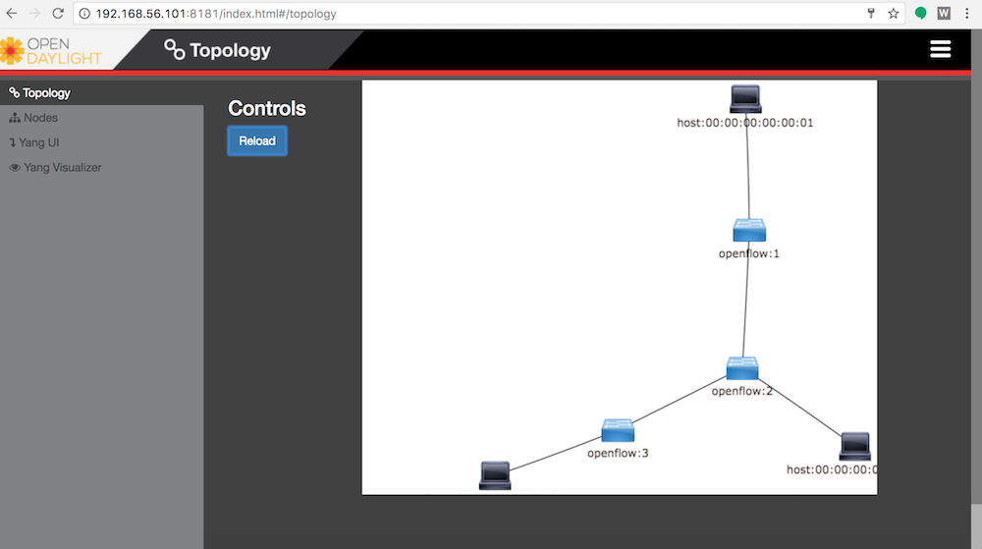

## What to turn in

1. Turn in the screen shots for Part A pingall function. [25 points]
2. Turn in the screen shots for Part A Opendaylight GUI as shown in figure above. [25 points]